ANCHORED AIRFIELD LIGHT MATS

MATERIALS
Airfield Light Matting:
The specifications in Tables 1 and 2 are those of the Echo Advisory TM Airfield Mats Systems.

TABLE 1 – AIRFIELD LIGHT MATTING PROPERTIES
PROPERTY | ASTM | SPEC-METRIC | SPEC-ENGLISH
Tensile Strength  with grain, min.  across grain, min. | D412  Die C | 4.8 MPa  2.1 MPa | 696.0 psi  304.5 psi
Elongation (%)  with grain, min.  across grain, min. | D412  Die C | 15  40 | 15  40
Hardness, Shore A | D2240 | 75-85 | 75-85
Tear Resistance  with grain, min.  across grain, min. | D624  Die B | 21 kN/m  44 kN/m | 119.7 pli  250.8 pli
Heat Aging Tensile, % max.  change in: Elongation, % max.  Hardness, Pts max. | D573  70 hrs  @ 70ºC | +/-25  +/-25  + 10 | SAME
Ozone Resistance  Tear across grain, kN/m min. | 80pphm  50hrs @  38ºC | 19.0 kN/m | 108.3pli
Specific Gravity |  | 0.9-1.3 | 0.9-1.3
Low Temperature Brittle  @-40ºC | D-2137  Method A | non brittle in both directions | SAME
Flammability Shall conform to current MVSS No.302, Flammability of Interior Materials.

TABLE 2 – AIRFIELD LIGHT MATTING MEASUREMENTS
Product Code | Description | Center Hole Dia. (inches) | Width (inches) | Length (inches) | Thickness  (inches) | Collar  Insert  Dia. (inches) | Application:
FM-1-8 | Elliptical shaped mat  Includes 8 staple stake anchors | 12 | 48 | 84 | .25 | No Insert | For Base Can Mounted Lights
FM-1-8wi | Elliptical shaped mat  Includes 8 staple stake anchors | 8 | 48 | 84 | .25 | 12 | For Stake Mounted Lights
FM-1-8wi-18 | Elliptical shaped mat  Includes 8 staple stake anchors | 12 | 48 | 84 | .25 | 18 | Dual Application: For Base Can and Stake Mounted Lights
SM-1 | 30’ Strip Mat  Includes 15 staple stake anchors | NA | 25.5 | 360 | .25 | NA | Perimeter Matting around Airfield Signs and Equipment
SM-2 | 60’ Strip Mat  Includes 30 staple stake anchors | NA | 25.5 | 720 | .25 | NA | Perimeter Matting around Airfield Signs and Equipment

Sustainability:
Mats shall be made of 100% recycled rubber, comprised of a combination of post-consumer and post industrial products.

Airfield Mat Anchors:
The specification in Table 3 is that of Echo Advisory TM Airfield Mat Anchors.

TABLE 3 – AIRFIELD MAT ANCHOR PROPERTIES
Anchors over perimeter of mats:
Anchor Length: | 11.25 inches
Anchor Top: | Square Staple Top 4 inches across top with 2 inches down pin
Drive Accommodation: | A ½ inch square shaped shaft to prevent twisting  when hammered into ground
Finish: | Dipped in rust proofing oil
Ground Penetration Mechanism: | A pointed shaft for mat and ground penetration with a  8 to 12 pound hand sledge hammer
Material | Steel

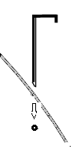
CONSTRUCTION METHODS

Weather Limitations:
Do not install anchored airfield mats when ground temperature is below 40°F, water is present in the area of the mat installation, or rain is imminent.

Preparation:
Confirm anchored airfield mat locations conform to locations and details shown in the Plans. Contractor will prepare the ground so that the mats are installed on a level and stable surface to prevent buckling, high spots, and erosion. Prior to installation of airfield mats, Contractor will correct trouble spots where the mat might not lay flat or where the elevation of the apron around the mat might be such that where a mower deck could scalp the ground. If there is uncertainty, Contractor should run mower equipment over the area to confirm proper mower deck ground clearance. In the event of existing thick vegetation, Contractor will trim the vegetation to ground level to minimize settling.

Installation:
All anchored airfield light matting shall be constructed in accordance with the manufacturer’s instructions, details, lines, grades, dimensions, and locations as shown on the plans or as directed by the Engineer. All matting shall be installed and secured in a manner rated for sustained 120mph hurricane force wind.

Mat Placement: Can Mounted:
The 12 inch center hole of the mat shall be fit snuggly around the can lid, while still allowing access to the bolts to remove the lid for general maintenance and troubleshooting of the light. Lay the mat over the light with the major axis of the ellipse pointing in the direction lawn mower equipment will travel. When using the dual application elliptical mat system, the collar insert is installed and removed through the 12” center hole for access to base can lid without removing entire mat.

Mat Placement: Stake Mounted:
The collar insert is to first wrap around the light for a snug fit up against the light post. The elliptical mat will overlay the center insert. Place the collar around the stake light. Sometimes the collar’s best fit it is to lay flat. Other times the collar can be pulled to have its edges over lapping, forming a conical shape sloping from the light post down to the outer edge. Place the elliptical mat over the collar on the light with the major axis of the ellipse pointing in the direction lawn mower equipment will travel.

Mat Placement: Strip
The strip matting will be used along buildings, fences, airfield signs or other equipment where vegetation control is desired to allow a contingency space between the object and mowing equipment. The strip mat can be cut to length on site with a razor knife. Mat strips shall adequately overlap each other at corners. Anchor placement shall be determined upon installation and anchor holes cut in the strip mat accordingly. The Anchor hole is best cut with a hole saw. When installing around an object with a concrete base, such as an airfield sign, the mat would over lap the concrete service 3-5 inches. A caulking adhesive such as a black top and roof sealant shall be used to seal the overlapping mat to the concrete base. The strip mat shall overlap at corners to at least 12 inches past the first common anchor. Anchors shall be placed at each corner and at least 2 to 3 feet apart.

Anchoring:
Anchoring will have site specific considerations with various techniques that the Contractor finds best. Generally the anchor can hammered into the ground and is strong enough to penetrate rocks and buried concrete splattering. NOTE: The mat has a small pilot hole for each anchor. Using this hole will position the anchor with its 2 inch pin reaching over the mats edge.

Quality Control:
Adjust anchors and mats if necessary to prevent buckling and to accomplish a flush installation. With cooperation from airport personnel, Contractor shall run mower equipment over the final airfield mat installations to ensure clearance. In the case of freshly graded soils or thick ground growth it is necessary to return to the mats a season later, once the soil and or the vegetation has settled, to confirm that anchors are keeping flush with the mat and the ground.

EXAMPLE MANUFACTURER INSTALLATION DRAWINGS:
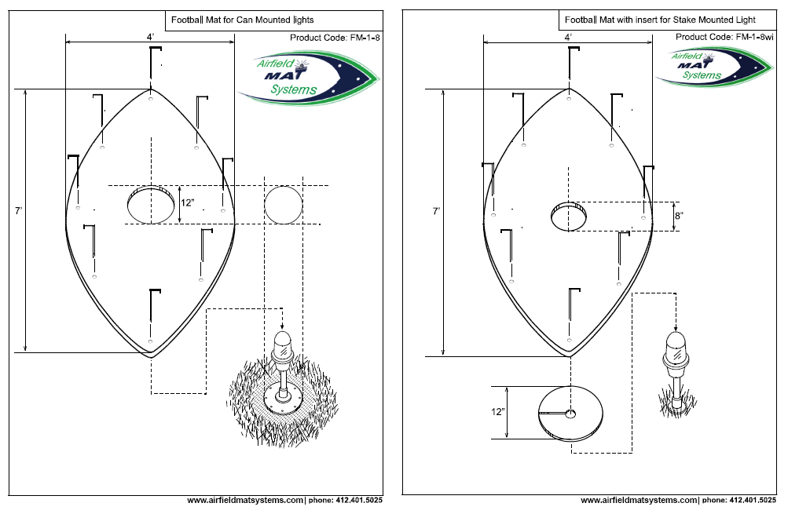
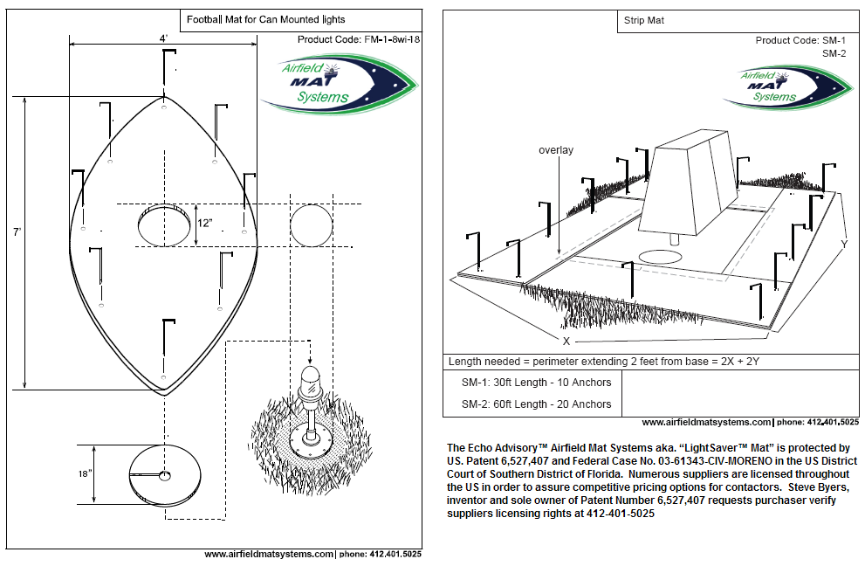

REIL Strip Mats
for runway end indicator lights (REILs)

The REIL Strip Mats are a specified with a custom fit for this project
- Approximately 53 inches wide (rough edge, +/- exact width tolerance)
- 30 feet long
- Three 12" diameter circle holes, down the center of the mat,
Hole centers at 5ft, 15ft, 25ft from the beginning edge.
- Three 18” Inserts with 2’ center holes
a slit from inner diameter to outer diameter (see drawing below)
- 30 anchors. Placed around perimeter
approximately 2’4” apart (including corners) not drawn.
See Table 3 for Anchor detail

Drawing:
Large mat 30 feet long about 53 inches wide
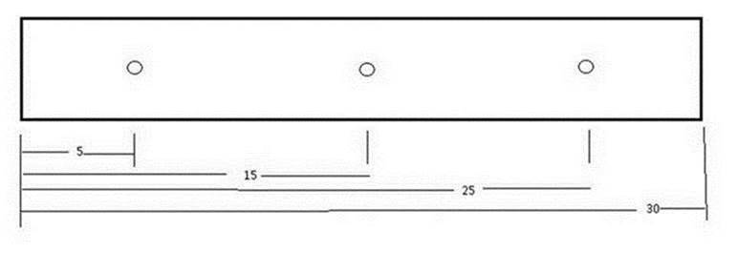

Inserts 18” diameter (qty 3)


